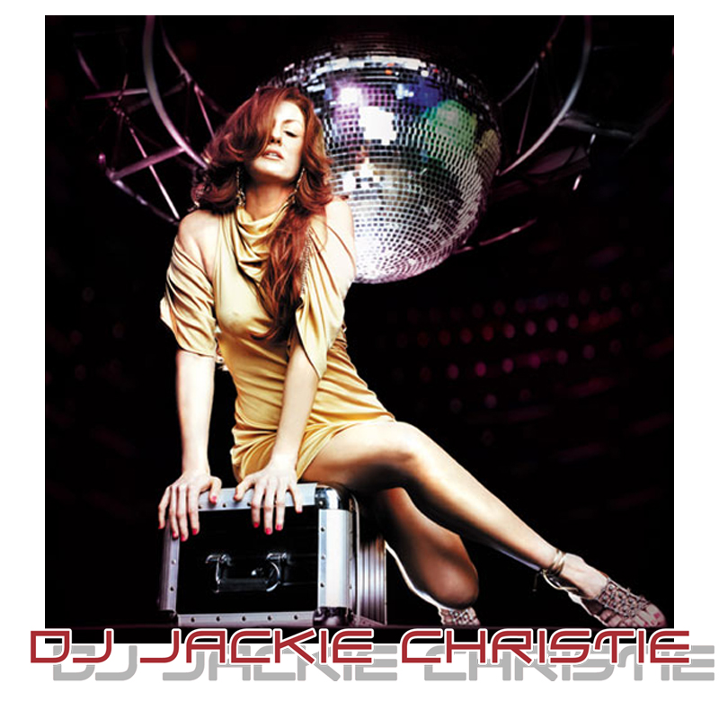



Detroit-born DJ Jackie Christie started spinning at 16. Cherished by MTV’s The Grind, she soon moved to New York and landed her first New York City residency at the famed Limelight.

Throughout the nineties, Jackie was omnipresent in the high point of club culture as a resident at some of the most sought-after clubs in the USA – the Limelight, Storm Raves, NASA at The Shelter, the Tunnel, Life, and at the Studio 54 hosted by Bacardi and Details Magazine.

With weekly residencies at New York's premiere club Spa (the hot spot from the creators of Club Life), by displaying her exceptional gift of mixing Jackie was no stranger to spotlight. Simultaneously, she would spend four days a month in LA taping a radio show for TheTruth.com while mixing for a Fujisankei Communications International Production, Soulook-Seize The Night. The latter was a music variety show aired in Japan and on NYC Cable.

In summer of 1997, Jackie Christie, under the name Shine, released her first single Bitch, followed up with Stimulating and Exciting (Groovillicious Records). Full length mixed CDs for Bacardi’s Seize The Night followed, featuring an original production by Jackie Christie The Children of Ohm Night Flavors. The next big project was the highly successful album Hard and Tasty Beats (Nervous Records). Remixes include R U A DJ by Kung POW (Extreme Records) and Yoko Ono's Open Your Box (Mind Train Records). A few years later, Jackie’s Hot and Tasty Beats was released, again by Nervous Records. It is a compilation of club anthems, mixed with the energy and expertise the people have regularly come to expect from this Queen of Clubs.

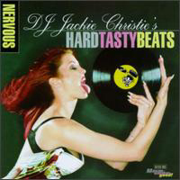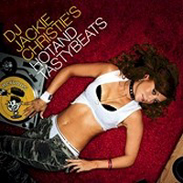

"I love gathering diverse talents around me and creating something new, fresh, trying new things, breaking down barriers and expectations," Jackie says.

Her career has shifted into high gear with the release of her debut album, Made 4 U, on which she brings home her vision of nightlife via eleven radiant tracks. The album was co-produced with Shane X. Conry, Jackie’s friend and a collaborator in remixing Madonna's Nothing Fails. The single made #1 on the Billboard Club Chart and stayed on

for 26 weeks. The first single Beautiful Day went to #14 on the Billboard Club Chart. An eclectic collection features America's No.1 drag queen, Lady Bunny (founder of NYC's annual Wigstock festival), House music pioneer Kraze (The Party, I Said Shuddup), club diva Sandy B (Make the World Go Round, Ain't No Need to Hide), and a newcomer Dirty Shane of Discomind. "I find strength, spice in variety: Just as I have a wonderfully rich mix of people in my life, so does the album.”
Jackie's skills, reputation, and passion for people have also earned her spots spinning at mega-clubs alongside Sasha, Digweed, Moby, and Carl Cox; hosting the Closing party of Club Universe with Cindy Lauper in San Francisco, and being mentioned in a book that soaked an era of New York City, Brett Easton Ellis’s Glamorama.
Her recent appearances are the last year’s First Love Parade in San Francisco for 75,000 people, and joining the float with the Ingrooves & Supper Club and Crystal Method in 2005.
Jackie’s music has also been heard in “Beauty Shop,” starring Queen Latifah, “Street Time” series on Showtime, Jenna Jameson’s One Hundred Hottest Hotties on VH1, and on previously mentioned MTV.

As evolved as ever, Jackie Christie continues to DJ in her hometown of New York City, and around the world.

JACKIE CHRISTIE REMIX HELPS MADONNA TO #1

Madonna's new single, “Nothing Fails,” which saw release Nov 23, 2003, rose to #1 on the Billboard Dance Sales chart, the chart that is based on sound scan sales. Remixes of Nothing Fails have charted to Top 5 in Spain, Portugal, Greece and now the US.

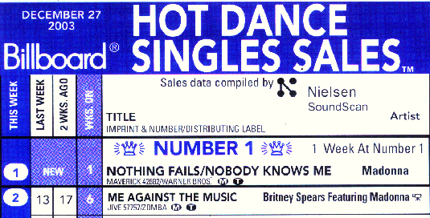

THE WOMEN WHO ROCK & NUMARK TURNTABLE DJ COMPETITION

Recently Christie hosted "THE WOMEN WHO ROCK - NUMARK - DJ COMPETITION" at HMV in New York City sponsored by: WKTU-FM (NY), Numark, Telex, Sam Ash, and Scratch DJ Academy. Party goers and music buyers gathered to witness a spectacular display of spontaneous turntable tactics and musical ingenuity, paired with fast-paced commentary and irreverent observations as female DJs competed to be the reigning woman who rocks! The WKTU-FM (NY) Party Crew was on-site with contests and prizes for the event.

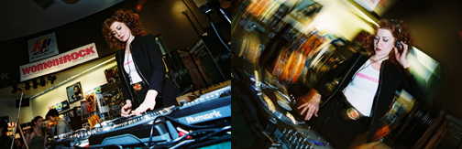

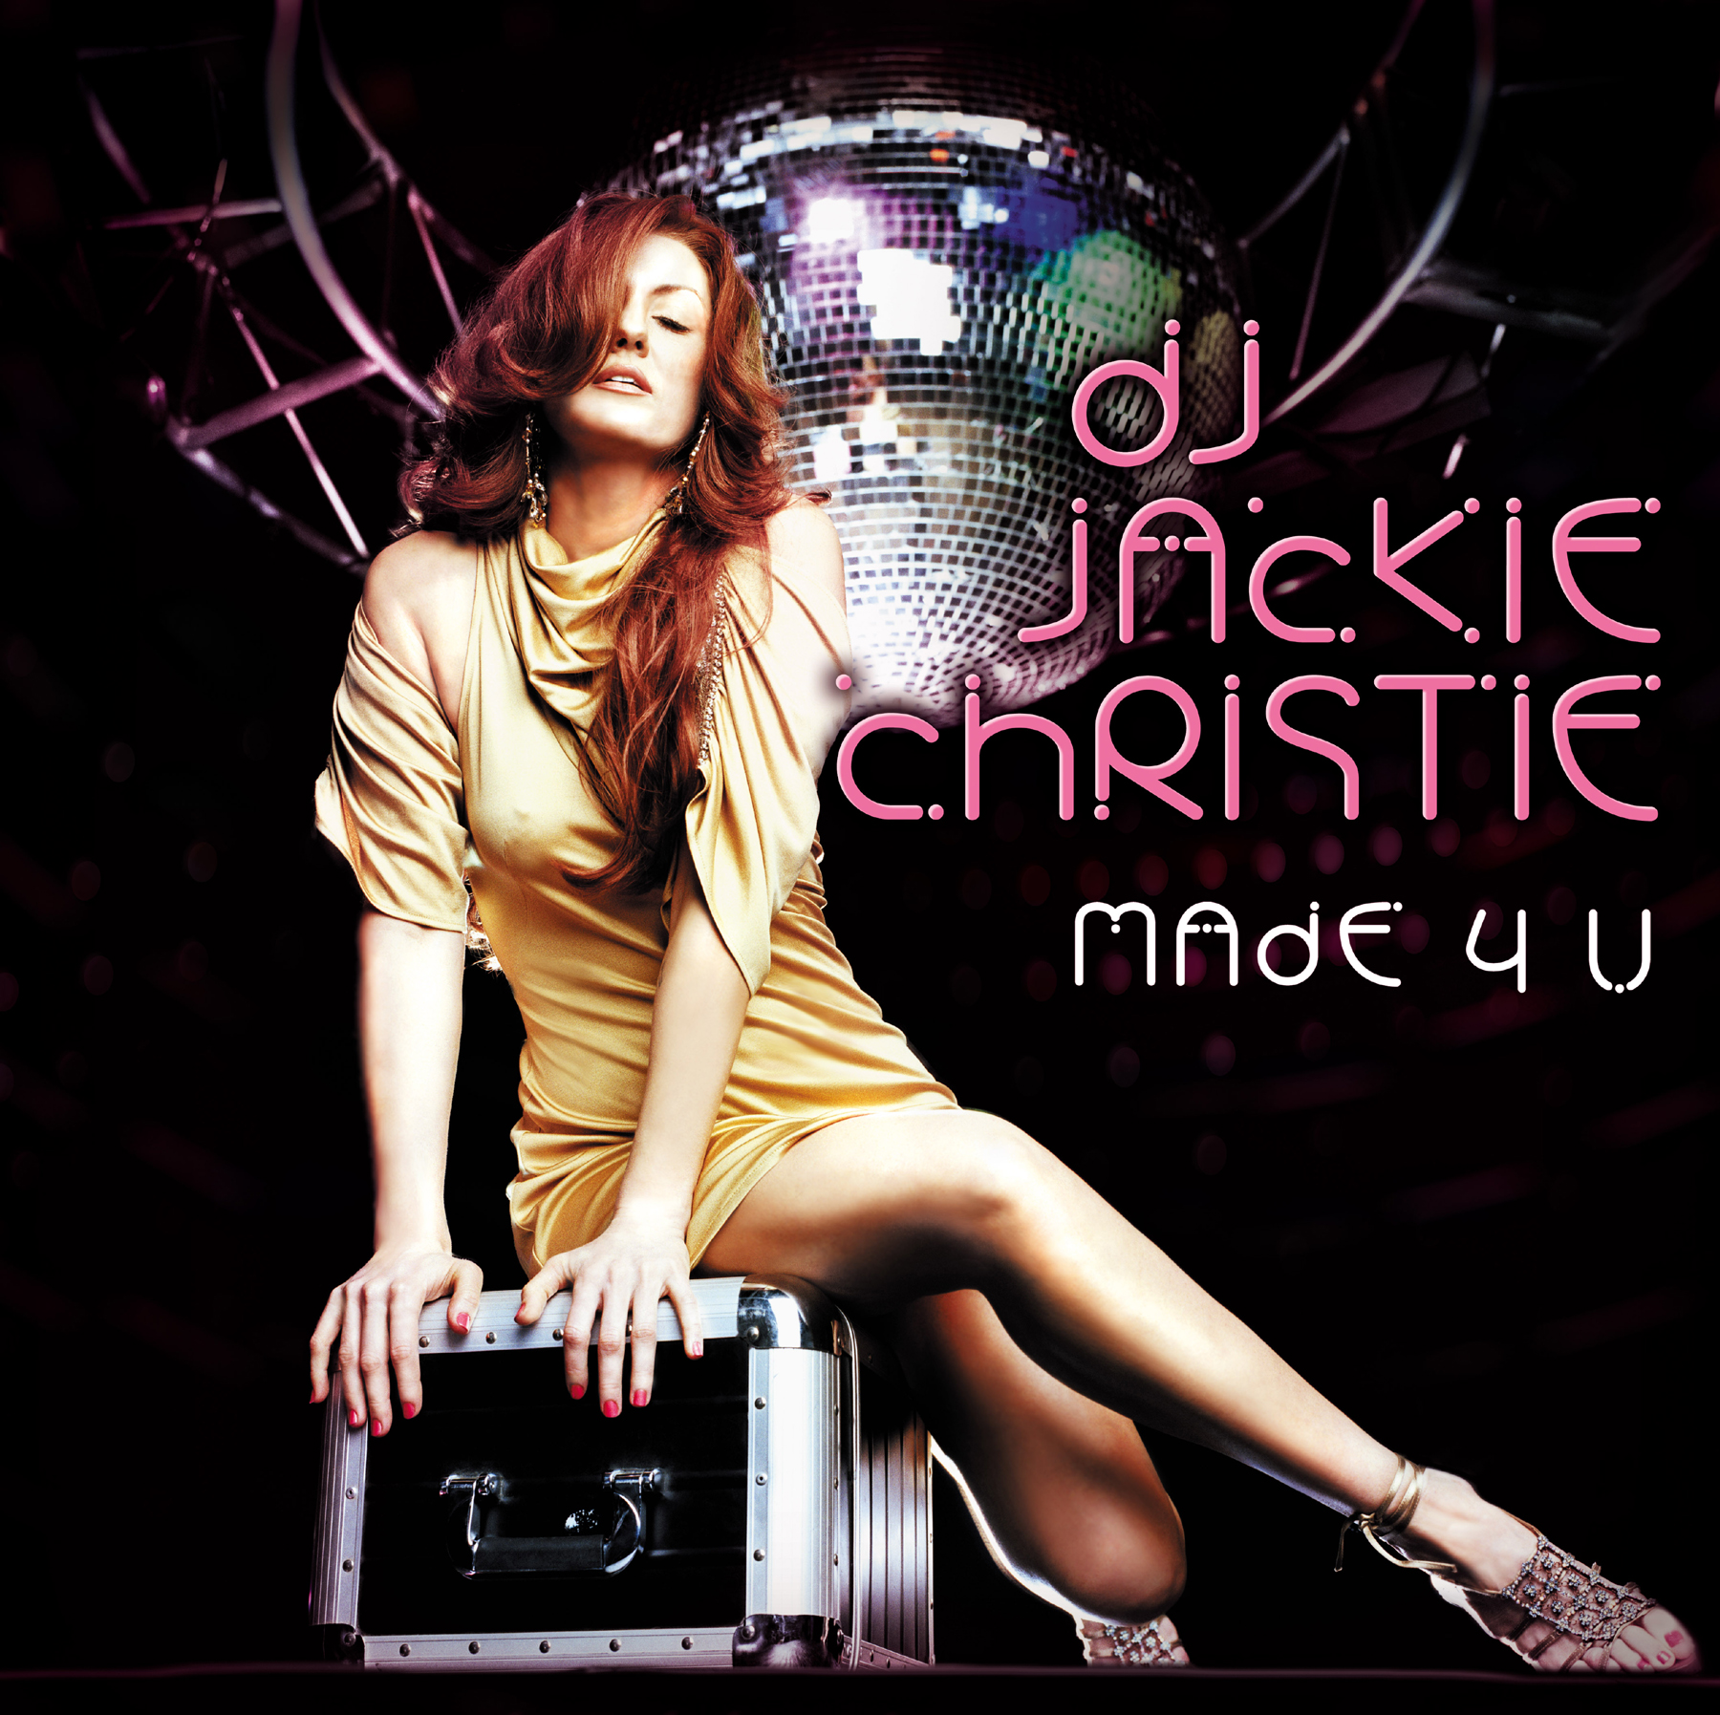

DJ JACKIE CHRISTIE
Made 4 U

DJ Jackie Christie Brings Her Debut Artist Album, Made 4 U!
DJ Jackie Christie has made her name moving crowds at legendary nightclubs worldwide, hosting nationally syndicated media programs (The Truth FM, MTV's "The Grind") and producing chart-topping remixes. Continuing her unstoppable path to multimedia superstardom, DJ Jackie Christie now brings her vision of nightlife home on her first album of all original material, "Made 4 U."
Released on October 26th 2004 by Motema Music, "Made 4 U" is a charged an eclectic collection of Dance, House and Pop-inflected tracks co-produced with Shane X. Conry, with whom Jackie recently remixed Madonna's "Nothing Fails" to #1 on Billboard and a 26 week run on the Dance sales chart. The success of Nothing Fails led to the signing by Motema and the MADE 4 U which features vocal collaborations with scene stealing gender illusionist LADY BUNNY; House music pioneer KRAZE ("The Party," "I Said Shuddup"), songbird SANDY B ("Make The World Go Round," "Ain't No Need To Hide") and newcomer DIRTY SHANE of DISCOMIND. "I love gathering great talent around me and creating new music, trying new things that break down the barriers of expectation," asserts Christie. "I find strength in diversity. It's what defines my life and the people in it."
Walking her talk, Christie's first single "Beautiful Day" is an infectious "feel good" anthem featuring Motema labelmates, DISCOMIND. Advance summer remixes of "Beautiful Day" courtesy of hitmakers Sueno Soul and Fishy Sounds will have dance mecca Ibiza abuzz with anticipation for the release of "Made 4 U."
A favorite subject of major U.S. dance music magazines, DJ Jackie Christie has also been featured in tastemaker essentials French Vogue, The New York Times, Paper Magazine, The Village Voice, URB, Vibe, HX and Time Out. Additionally, Christie holds the coveted distinction of being the first mixologist on the cover of industry bible DJ Times. Sweetening the visual pot on "Made 4 U" is ravishing imagery by renowned French lensman Jean-Marc Lubrano.

Quotes
"A Wicked Floorburner!"
------- Phil Turnipseed, DJ Times
"Hey Miss DJ"! Her Reputation Will Now Be Fully Established!"
--- HX Magazine
"We Now Step Beyond Her Electrifying DJ Sets!"
--- The Vibe
"Disco Bunny From Gotham Provides Transcendent Experience!"
----- Time Out Magazine
"A Must Have From A NY Legend!"
-----Egg Magazine
"House Music's Femme Fatale Returns To The Dance Floor!"
----- MCO Magazine

